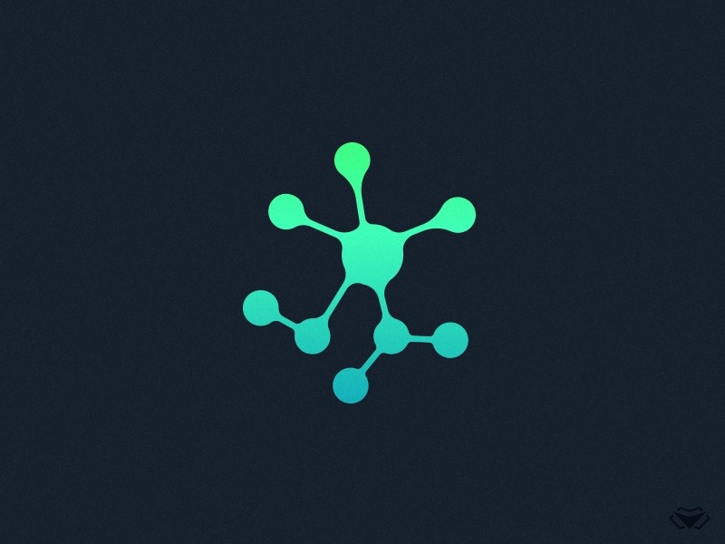

**TEAM 9 MEETING**

**MINUTES**

**Week 9 Group Meeting**

**Meeting Details**

|  |  |
| --- | --- |
| **Team Name:** | Team 9 |
| **Meeting Date:** | 1st September |
| **Time:** | 9:15AM – 9:45AM |
| **Venue:** | Teams Call |
| **Attendees:** | Isaac, Rodney, Dhruv, Dennis, Hadi |
| **Absent Members:** | Matthew, Josh |
| **Minutes Taker:** | Isaac |

**Agenda Details**

|  |  |
| --- | --- |
| Tasks | Sub-tasks |
| Discussions/Clarifications | * Demonstrate what has been done so far * Review requirements and 100$ page * Divide tasks from the issues page |
| Next Meeting | * Share progress on assigned issues |

**Meeting Commences (9:15am)**

Auditor apologises for not being able to make it in person

Isaac Demonstrates recent progress on the project. Shows features such as the pause screen, adding particles, the time scale and the FPS counter. Suggests areas for improvement such as incorporating a measurement tool and adding more options to the add particle menu.

Dhruv Suggests we need to review our requirements

Dhruv The client was impressed with our progress so far

Rodney Next client meeting we need to ask for clarification about ray casting and the physics engine

Dennis [arrives]

Dhruv [move on to the git issues]

Dhruv Collision physics is the highest priority task, and we should split it into two tasks – particle-particle collisions and particle-boundary collisions

Isaac We need to include these git issues in the requirements tab of the time sheet

Dhruv We are yet to incorporate the destroy feature

Isaac We can just implement the framework to delete a particle, however ray casting is needed to select the particle with the mouse

Rodney Agrees

Dhruv Need to discuss box invariance

Isaac It should be incorporated by adding a partent class to the particle system.cs class, that holds a list of sub systems.

Isaac We also need to make our code more robust and clean. For example adding boundary and error checks, and error handling.

Dhruv Opens QA Issues

Dhruv We should assign tasks on git issues

Matt - 3D environments

Dennis – particle database

Isaac – create and destroy

Rodney – box collisions + particle collisions

Dhruv - box invariance

Josh - time and length scale visualisation, measuring, extracting measurements

Dhruv reviews $100 test

Dhruv We should have basic collision detection before next client meeting

Dhruv Reiterates that we need clarification on the physics engine

Isaac Will type up these minutes and send them to Dennis to format them

Dennis [Agrees]

**Finishing at 9:45am**